**Forbes billionaires 2022- Exploratory data analysis and visualization**

# Overview

# Globally, individual and community life have been negatively impacted by COVID-19 pandemic and the war going on between different countries especially between Russia and Ukraine. The health problems, social, political, and economic impact is enormous. For instance, taking the economic impact, it has been reported that global economy has shown slowdown and inflation rate on rise in many countries (1). As a result, many industries and companies lost their net worth compared to previous years. As expected, the above-mentioned problems hit world’s billionaires net worth too. Forbes reported reduced list of billionaires in 2022 compared to previous years and variation in countries included in the list (2) but surprisingly there were new people who joined the world billionaire list in 2022. In this project, exploratory data analysis was performed to answer the following questions.

# Questions

* Who are the top 10 billionaires with the highest net worth in 2022
* Who are the top 10 youngest billionaires in 2022
* Who is the youngest billionaire with the highest net worth in 2022
* Which age group has highest net worth in 2022
* Which countries have highest number of billionaires in 2022
* Which countries have highest cumulative billionaires net worth in 2022
* Which industries have highest number of billionaires in 2022
* Which industries have highest cumulative billionaires net worth in 2022
* Which sources have highest number of billionaires in 2022
* Which sources have highest cumulative billionaires net worth in 2022

# Methods

# Data source

World’s billionaires’ of 2022 data were curated by Forbes (2). This data was obtained from **kaggle** (3) in October 2022,and csv file was downloaded to local machine. Jupiter notebook was used to analyze the data. First off, necessary libraries were installed and imported as mentioned below. This included Pandas, NumPy, matplotlib and Seaborn.

# Then, data were imported using read_csv() method.

# Data were inspected using head (), info (), column () methods to get general information about the data.

# There were total of eight columns with 2600 entries. Of these, five of them were object data type whereas three of them were integer. The columns were the following: 'Unnamed: 0', 'rank', 'name', 'networth', 'age', 'country', 'source', and 'industry'.

# Data cleaning

# The cleaning process includes: - Checking for duplicates, missing values, inconsistency in naming and data type, verifying and validating the data with their respective fields. Accordingly, the following cleaning were made.

# There were columns that were not needed for this analysis. So, the columns labeled as ‘unnamed’ and ‘rank’ were excluded from the data frame.

# All column names were in lower case. I preferred to have upper case for the first letter. using rename method the first letter for each word were changed. In addition, the $B sign were included on the networth column to reflect the unit of measurement.

# Also, Networth column has extra characters. so, those characters ('$', “B”) were get rid of using the str. replace method. i.e ('$', 'B') were replaced by empty ('')

# Networth and Age columns were object and integer data type, respectively. So, the data type were changed to float using to_numeric() and astype() methods. Then, the data type was checked using dtypes method.

# Presence of duplicates in the data were assessed using duplicated() method whereas missing values were checked using isnull() method.

# Distribution of continuous variables were assessed using histogram and boxplot.

# Data Transformation

# Age variable was transformed to create new variable called Agegroup. To make the categories comparable I used 20 years gap for each age group. Then, it was categorized as "below 40", "40 - 59", "60 - 79", "80 and above "

# Analysis

# Data were presented using mean (± standard deviation (SD)), and median (interquartile range [IQR]) for continuous normally distributed and skewed variables, respectively. Categorical variables were presented using frequencies (n) and percentages (%).

# IQR calculated by subtracting the 25th percentile (1st quartile) from the 75th percentile (3rd quartile). It shows the spread of the middle 50% of a dataset.

# Results

Mean (±SD) age of world’s billionaire was 64.3(13.2) years. The minimum and maximum age were 19 and 100 years, respectively. Half of the billionaires were in the age range of 60 - 79 followed by 40 - 59 years **(Fig 1)**. There were only twelve billionaires who were under the age of 30. The median net worth of the billionaire was 2.4 billion$ with IQR of 3 in 2022. The 25th percentile of billionaire’s net worth was below 1.5B$, 75th percentile of billionaire’s net worth was below 4.5B$, 95th percentile of billionaire’s net worth was below 14B$, 99th percentile of billionaire’s net worth was below 47.3B$ i.e only one percent of them having above 47.3B$ of net worth in the year 2022 (**Table 1).**

**Table 1: Forbes world’s billionaire description, 2022**

|  |  |
| --- | --- |
| Variables | Mean(±SD) or median (IQR) or n (%) |
| Age, years | 64.3 (±13.2) |
| Age category, years |  |
| Under 40 | 67 (2.6) |
| 40 - 59 | 826 (31.8) |
| 60 - 79 | 1313 (50.5) |
| 80 and above | 393(15.1) |
| Net worth, B$ | 2.4 (3) |
| 25th percentile net worth | 1.5 |
| 75th percentile net worth | 4.5 |
| 95th percentile net worth | 14 |
| 99th percentile net worth | 47.3 |

Fig 1. Forbes billionaires age classification in 2022

**Who are the top ten billionaires with the highest net worth in 2022**

Elon Musk, Jeff Bozes, and Bernard Arnault and family were the leading billionaire in the world in 2022 with net worth of 219, 171 and 158 B$, respectively (**Fig 2**). Elon Musk, who tops the World’s Billionaires, was the only person who had above 200B$ worth.

Fig 2. Top ten richest billionaire in 2022

only 25 billionaires’ worth was greater >50B$ in 2022. On the other hand, only three billionaire worth was greater than 150B$.

Among the top ten billionaires, majority were from the USA and only two were from France and India. These two billionaires were Bernard Amault and Family from France and Mukhes Ambani from India (**Fig 3**).

Fig 3. Top ten richest billionaire by country in 2022

**Who are the top 10 youngest billionaires in 2022**

There were 12 billionaire whose age was under 30 years. Of this, only one billionaire’s age was below 20 years. Kevin David was the youngest of all who was only 19 years from Germany. Kevin David, Wang Zelong and Pedro Franceschi were the top three youngest billionaire in the world. The below figure shows the top 10 youngest billionaires in 2022 (**Fig 4**).

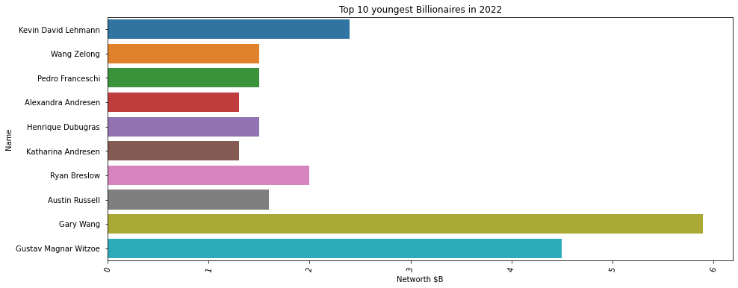

Fig 4. Top ten youngest billionaire in 2022

**Who is the youngest billionaire that has highest net worth in 2022**

Gary Wang from the USA has the highest net worth among the young billionaires. His worth was about 5.9B$.

**Which age group has highest collective net worth in 2022?**

Age group 60 -79 years had the highest wealth of 6.1 trillion dollars followed by age group 40-59 years with a collective worth of 3.8 trillion dollars. Billionaires under the age of 40 had the least net worth which is about 366 billion dollars (**Fig 5**).

Fig 5. Total net worth of billionaire in each age group in 2022

**Which countries have highest number of billionaires in 2022**

USA, China, India, Germany, and Russia were the top 5 countries with highest number of billionaires (**Fig 6**).

Fig 6. Number of billionaires in each country in 2022

**Which countries have highest net worth in 2022?**

USA is leading the world in Forbes billionaire list by having 719 billionaires with a collective worth of $4.7 trillion in 2022. China being the 2nd in the world’s billionaire list had a worth of 1.9 trillion $ from 515 billionaires. On the other hand, India which is the 3rd country on Forbes billionaire list had a total of 161 billionaires collectively having 745 billion $ (**Fig 7**).

Fig 7. Total net worth of each country in 2022

**Which industries have highest number of billionaires in 2022**

Finance & Investments, Technology, Manufacturing, Fashion & Retail, and Healthcare were the top 5 industries that had highest number of billionaires in 2022 (**Fig 8**).

Fig 8. Number of billionaires in each industry in 2022

**Which industries have highest net worth in 2022?**

Technology, finance and investment, and fashion and retail were the top three industries with the highest net worth in 2022 (**Fig 9**).

Fig 9. Forbes billionaire’s net worth per each industry in 2022

**Which sources have highest number of billionaires in 2022**

Real estate leads worlds billionaires’ source of worth followed by investment and pharmaceuticals (**Fig 10**).

Fig 10. Number of billionaires in each source in 2022

**Which sources have highest net worth in 2022?**

The figure below shows the top ten sources with highest net worth in 2022. Real estate being the top sources having nearly 600 billion dollars. Diversified and investment were the 2nd and 3rd sources with highest net worth each having 382 and 358 billion dollars, respectively. Google, Walmart, Microsoft and Tesla, SpaceX were also among the top ten sources based on total net worth.

Fig 11. Forbes billionaire’s net worth per each source in 2022

# Conclusions

Elon Musk tops the world’s billionaires list in 2022 with a net worth of 219 billion dollar whereas Kevin David was the youngest world’s billionaires with a wealth of 2.4 billion dollars. Half of the billionaire were in the age range of 60 - 79 years having a cumulative worth of 6.1 trillion dollars.

United States of America leads the world, with 719 billionaires worth a collective $4.7 trillion. China being 2nd in the world’s billionaire list has a total of 515 billionaires worth a collective $1.9 trillion based on Forbes 2022 report.

Eight of the top ten billionaire were from the USA including the top one billionaire Elon Musk. France and India were the only countries that have billionaire in the top ten list. These two billionaires were Bernard Amault and Family from France and Mukhes Ambani from India.

The top industries with the highest worth in 2022 were Technology with a worth of 2.2 trillion dollars followed by finance and investments, and fashion and retail. On the other hand, Real estate, Diversified and investment were the top three sources with the highest wealth having nearly 600, 382 and 358 billion dollars, respectively. Google, Walmart, Microsoft, and Tesla individually were able to join the top ten sources based on their total net worth.

Limitations

Since the data did not have sociodemographic of the billionaire including sex, it was not possible to analyze sex variation based on net worth. Future analysis might focus on identifying trends of worlds billionaire list overtime and include basic demographic factors like sex to provide comprehensive insight. In addition, similar analysis should be done based on future release of latest data from Forbes to explore if there is any change in the order of billionaires list and countries included.

# References

# Stagflation Risk Rises Amid Sharp Slowdown in Growth. <https://www.worldbank.org/en/news/press-release/2022/06/07/stagflation-risk-rises-amid-sharp-slowdown-in-growth-energy-markets>

# Forbes World’s Billionaires list. <https://www.forbes.com/billionaires/>

# <https://www.kaggle.com/datasets/jjdaguirre/forbes-billionaires-2022>

# 